Bioprinter Progress report – Month 2
Adrian Bowyer, Jean-Marc Giacalone and Sally Bowyer
RepRap Ltd and eMaker Ltd
20 July 2016

Summary

1. Gel printing
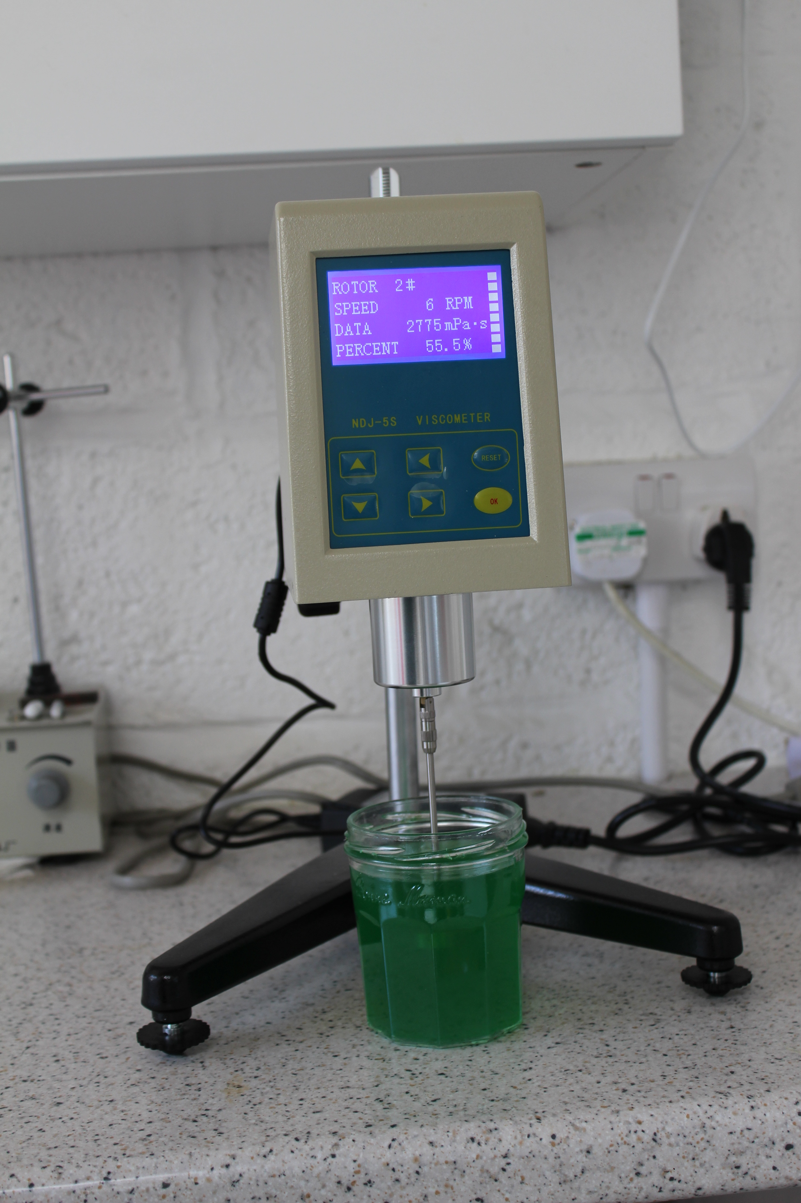

Our viscometer has now arrived and been commissioned. It works well, and is simple to use. It is shown above measuring the viscosity of the 50:1 weight water:sodium-alginate gel that we have been using for some of our experiments (which has 2.7 Pa.s viscosity, incidentally). Its only drawback is that it requires quite a large sample ( > 400ml).

2. Other Developments

2.1 I2C Digitally-controlled Pressure Regulator
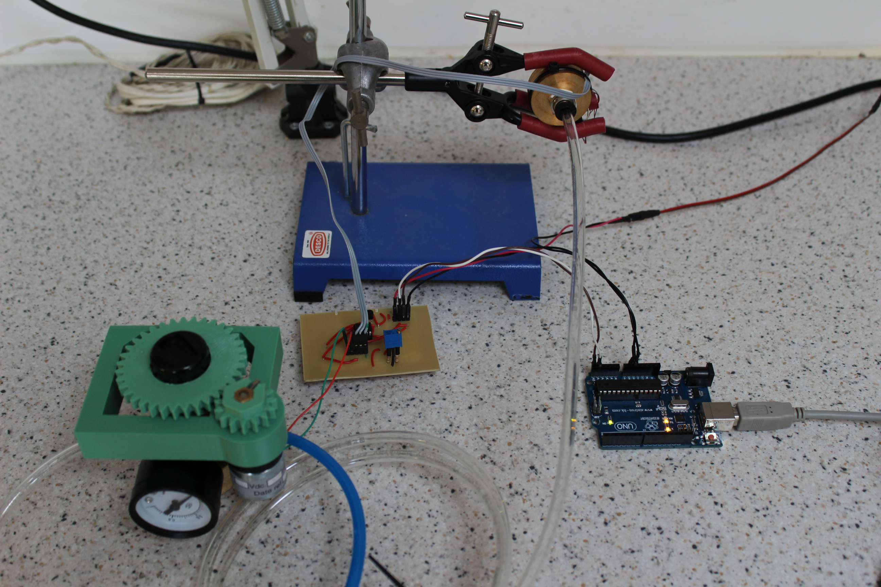
Work on the digitally-controlled pressure regulator has continued, with a test rig now assembled (above). A program has been written for the ATTiny chip which allows it to both communicate a pressure to a controlling Arduino in order to monitor the level, and also to drive the DC motor (attached to the pressure regulator) in both directions, in order to set a pressure instructed by the Arduino.

The pressure regulator has been assembled and shown to work with the control circuitry; in addition the Honeywell 40PC pressure gauge is also being investigated as a possible component for the system.

3. Work to be done next

Now that we have both rival gel-extrusion systems working we will standardise on a set of experimental conditions and compare their performance. As a result of that comparison we will decide the one to use in the final system.

The experimental standards will be the most extreme limits of the specification for the Bioprinter. That is to say that we will use gels of the highest and lowest viscosities required being deposited through the broadest and finest nozzles.

As mentioned above, we will use oil-based gels for the experiments. This will allow us to take micrographs of the resulting prints and from those gather measurement statistics on the smoothness, thickness and repeatability of the prints created.

We will also start work on the tool changer, as described above. We will build a system together with a tool probe and use the combination to check the accuracy and repeatability of the changer.

Appendix

G Codes for stepper syringe test

G90
M83
G92 X0 Y0 Z0.2
G1 E10 F200 ;flush nozzle
G1 E-10 F500 ;retract
G1 X10 Y10 F500 ;move to start
G1 E10 F500 ;un-retract
G1 X50 E0.3 F400 ;print square
G1 Y50 E0.3
G1 X10 E0.3
G1 Y10 E0.3
G1 E-10 F500 ;retract
G1 X0 Y0 F500 ;move clear

